**Name:-** Tanishq. Dhokariya

**Technology:-** DJANGO, HTML

**BACKEND**

* **Add Course Entity:**

from django.db import models

class Course(models.Model):

    course_id = models.AutoField(primary_key=True)

    course_name = models.CharField(max_length=100)

    course_code = models.CharField(max_length=20, unique=True)

    course_duration = models.IntegerField()

    def __str__(self):

        return f"{self.course_name}"

class Student(models.Model):

    student_id = models.AutoField(primary_key=True)

    name = models.CharField(max_length=100)

    # Add other student fields

    course = models.ForeignKey(Course, on_delete=models.CASCADE)

    def __str__(self):

        return f"{self.name}"

[**http://127.0.0.1:8000/admin/**](http://127.0.0.1:8000/admin/)

**Course: Students:**

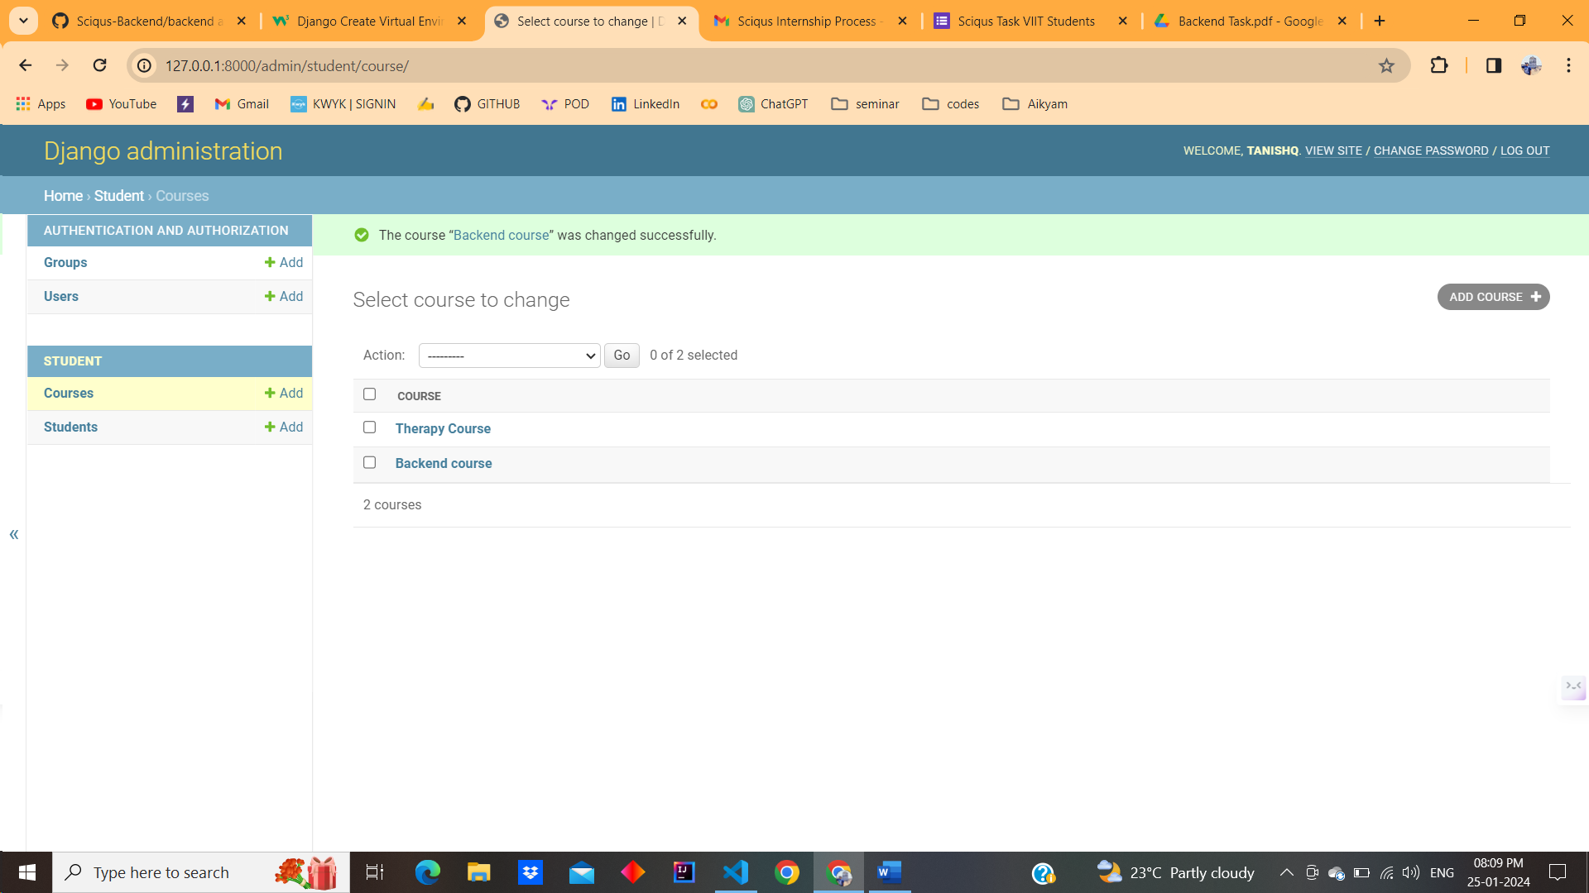 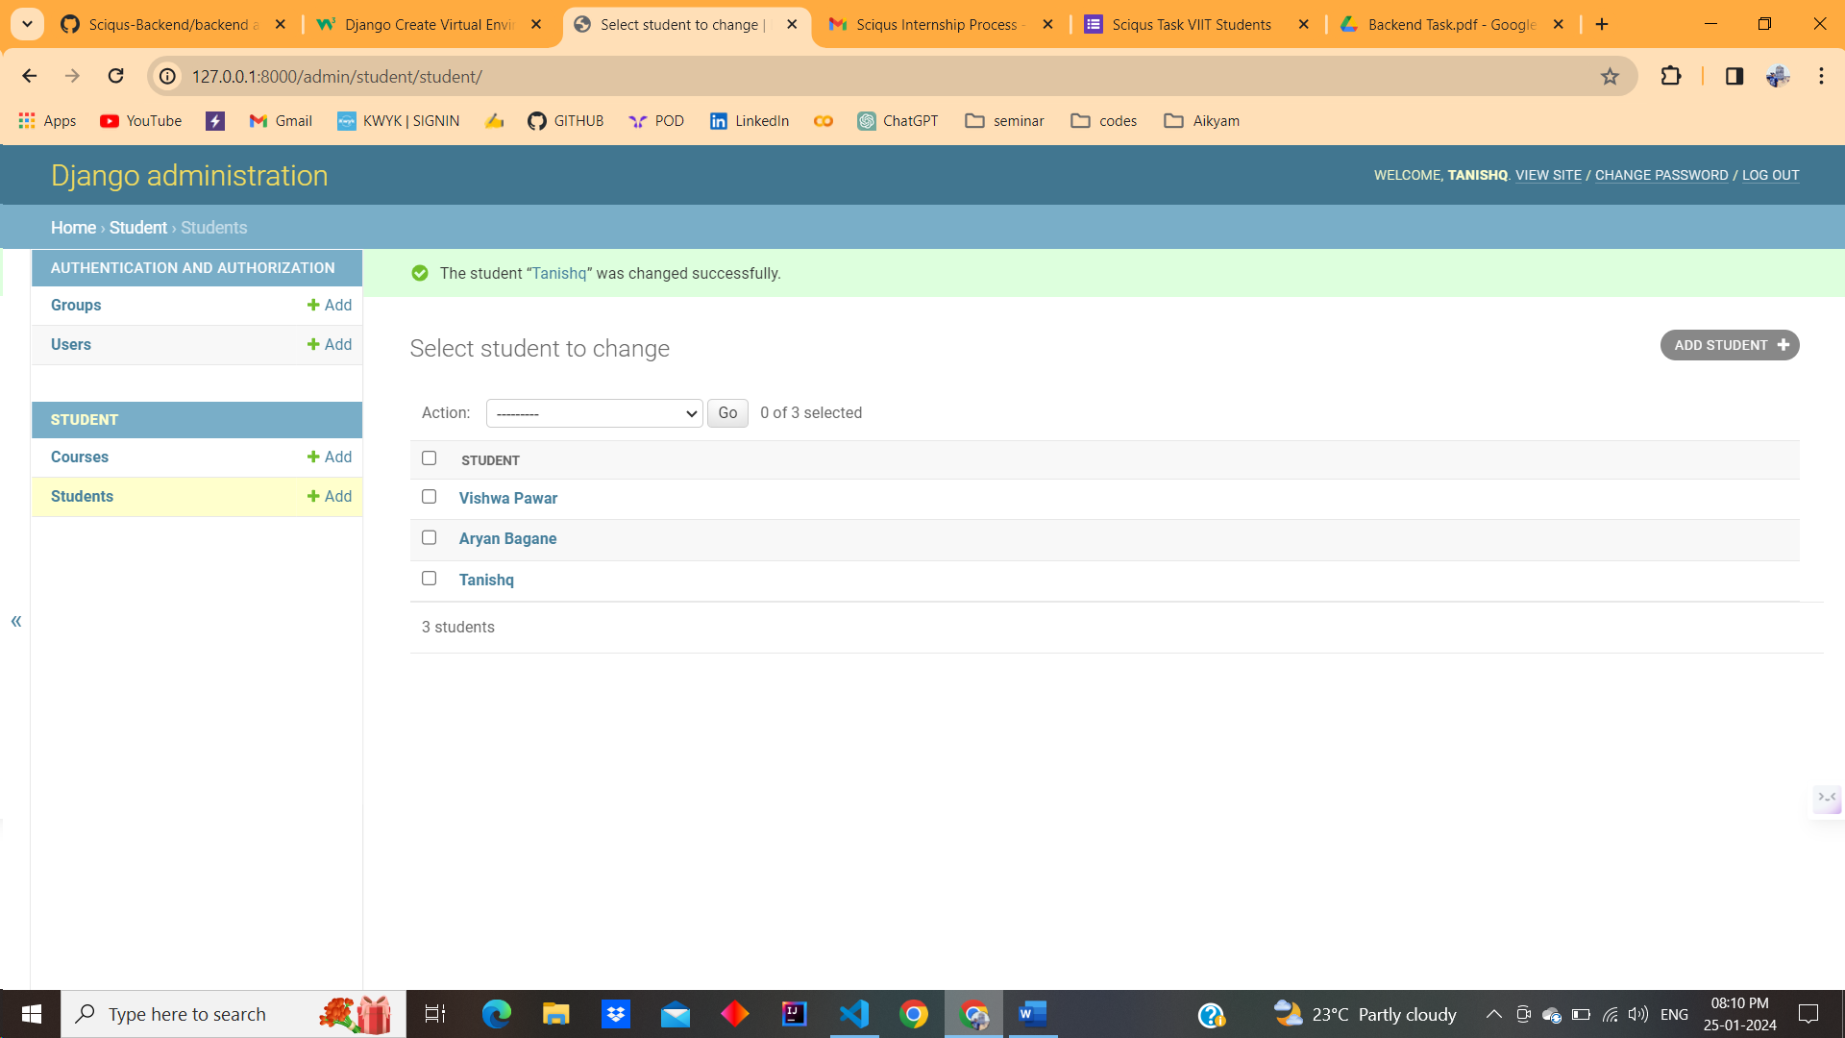

* **Enhance Student Registration:**

def register_student(request):

    if request.method == 'POST':

        form = StudentRegistrationForm(request.POST)

        if form.is_valid():

            form.save()

            return redirect('success_page')  # Redirect to a success page or any other page

    else:

        form = StudentRegistrationForm()

    return render(request, 'student/registration_template.html', {'form': form})

**Form**

<form method="post" action="{% url 'register_student' %}">

    {% csrf_token %}

    {{ form.as_p }}

    <button type="submit">Register</button>

  </form>

[**http://127.0.0.1:8000/register/**](http://127.0.0.1:8000/register/)

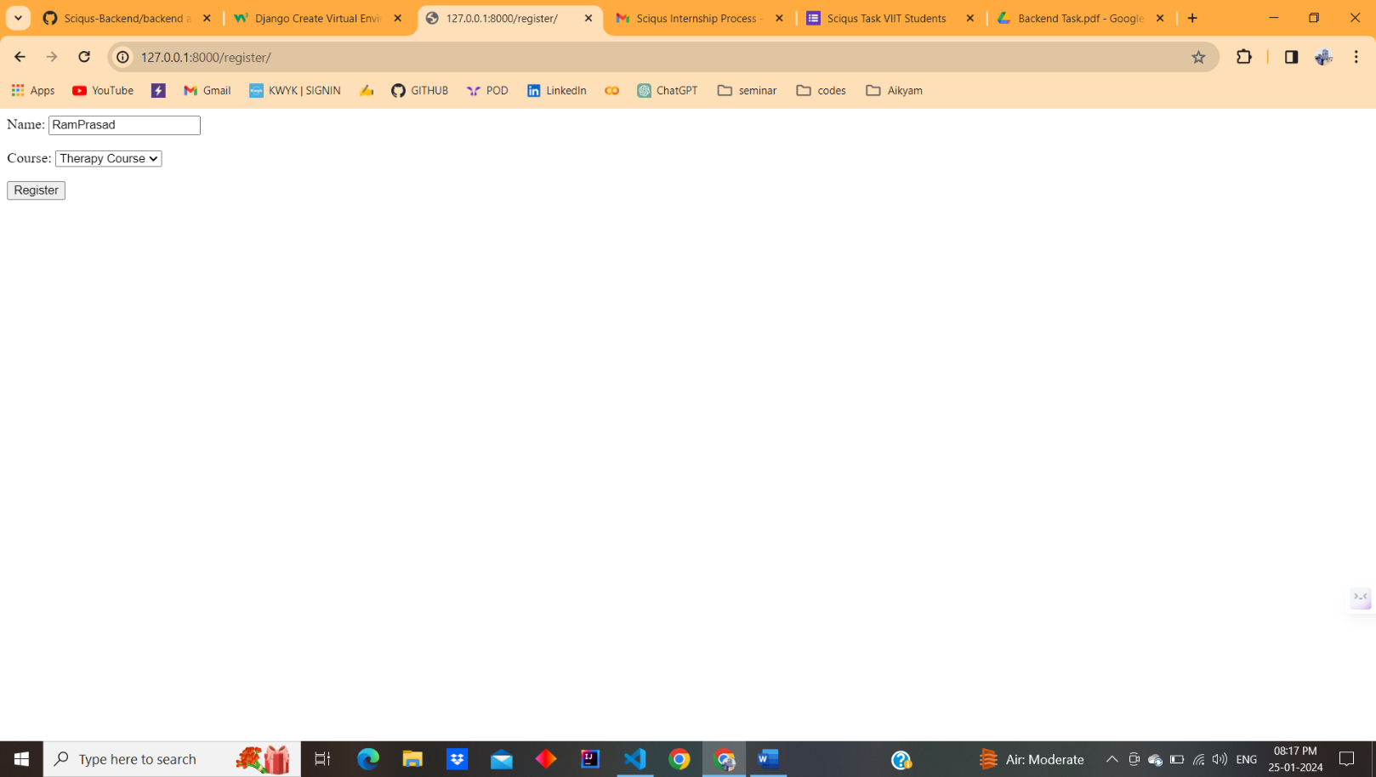

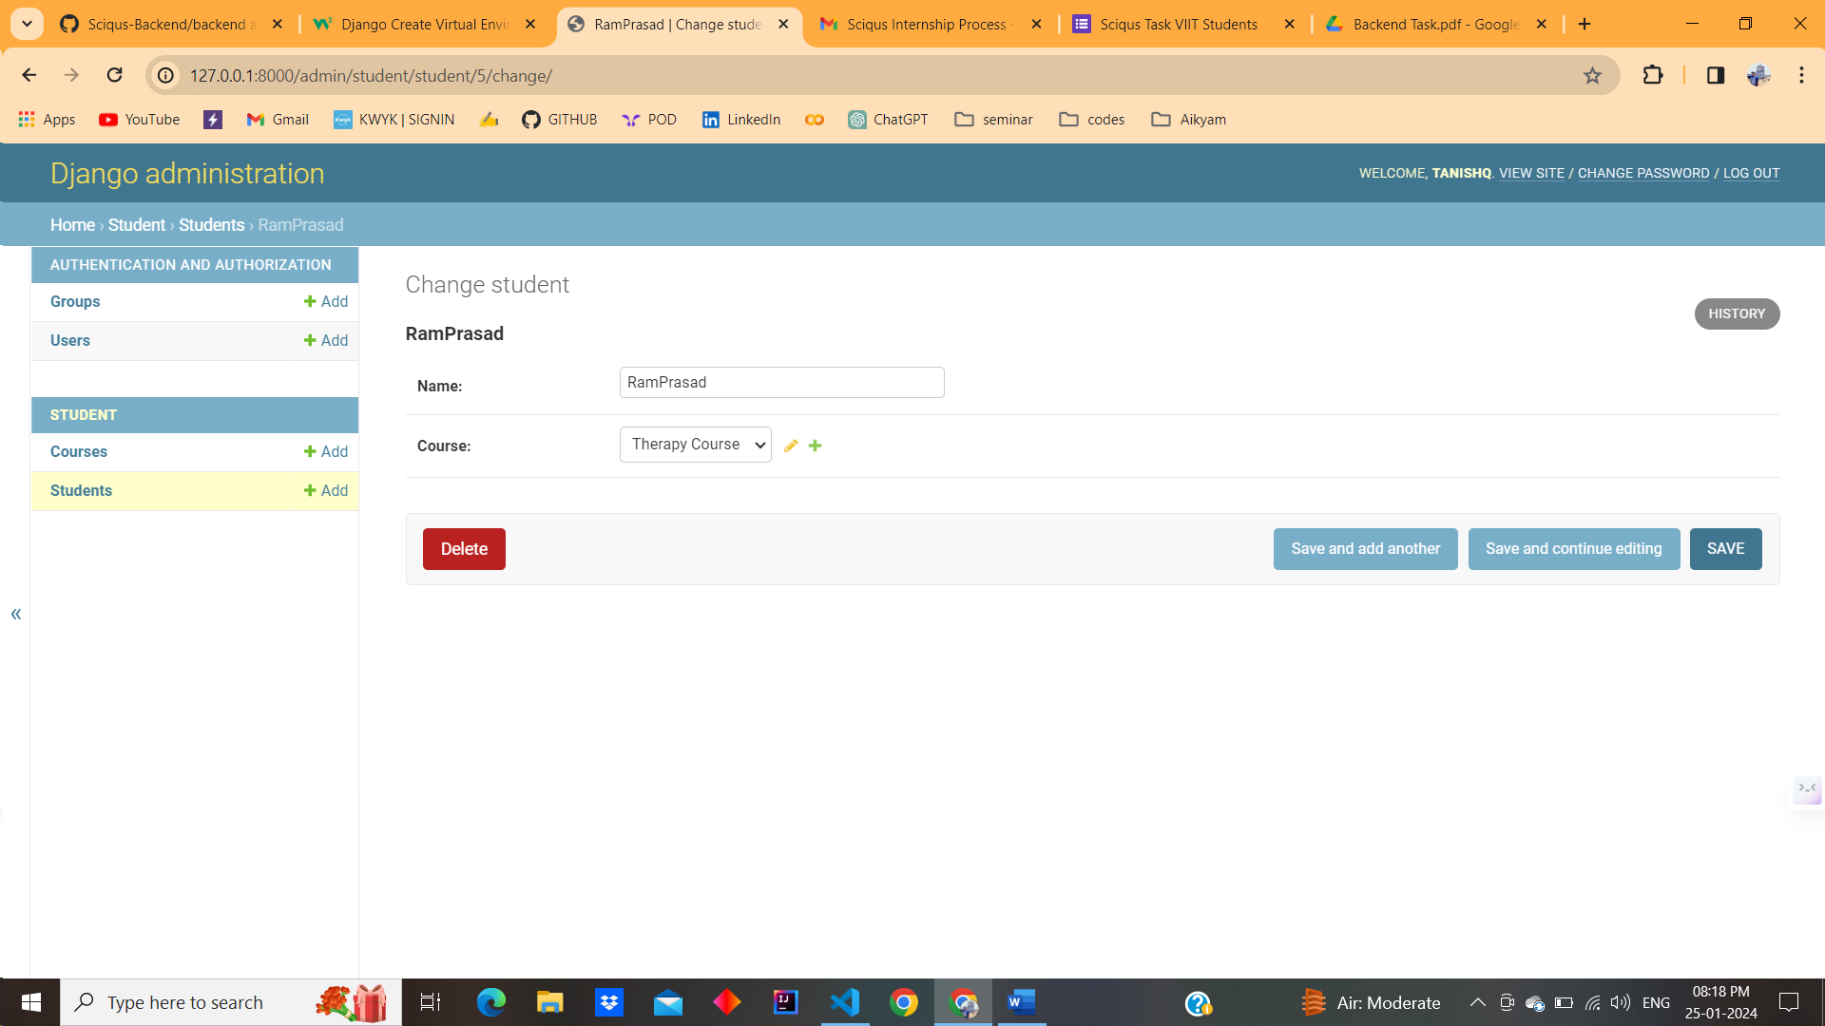

* **Show Student Details with Course Information:**

from .models import Student

def student_list(request):

    students = Student.objects.select_related('course').all()

    # Use select_related to fetch related course information in a single query

    context = {'students': students}

    return render(request, 'student/student_list.html', context)

{% for student in students %}

  <div>

    <h3>{{ student.name }}</h3>

    <p>Course: {{ student.course.course_name }}</p>

    <!-- Edit Button -->

    <a href="{% url 'edit_student' student.pk %}">Edit</a>

    <!-- Delete Button -->

    <a href="{% url 'delete_student' student.pk %}">Delete</a>

  </div>

{% endfor %}

[**http://127.0.0.1:8000/student/**](http://127.0.0.1:8000/student/)

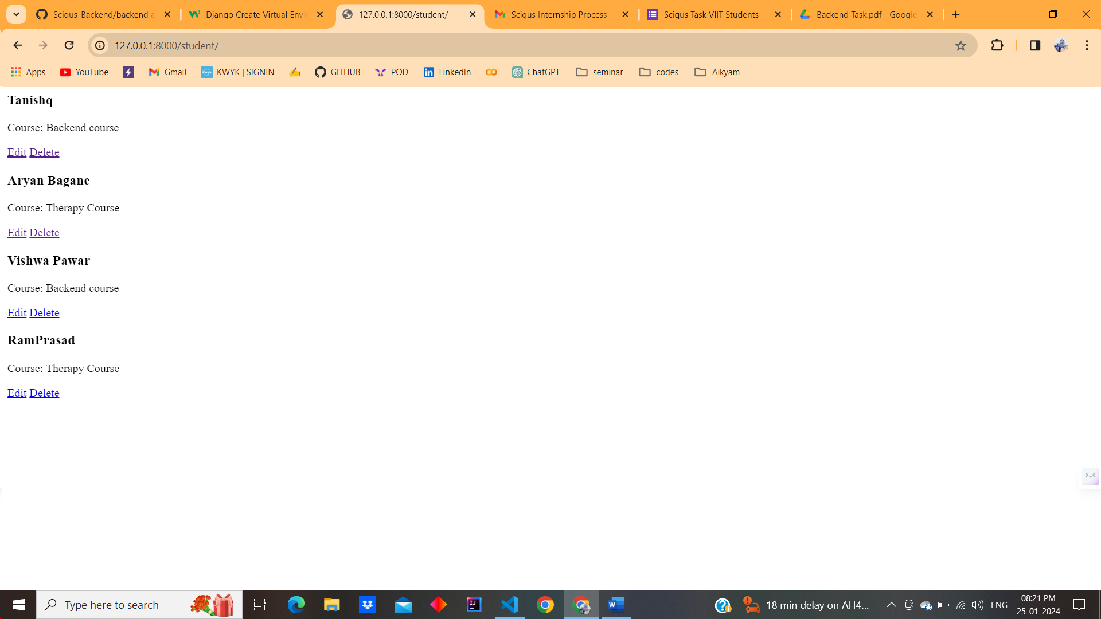

* **Show all Students Details Enroll in the Course:**

from .models import Student, Course

def students_in_course(request, course_id):

    course = get_object_or_404(Course, pk=course_id)

    students = Student.objects.filter(course=course)

    context = {'course': course, 'students': students}

    return render(request, 'student/students_in_course.html', context)

<h2>Students enrolled in {{ course.course_name }}</h2>

{% for student in students %}

  <div>

    <h3>{{ student.name }}</h3>

    <!-- Add other student information as needed -->

  </div>

{% endfor %}

[**http://127.0.0.1:8000/course/1/**](http://127.0.0.1:8000/course/1/)

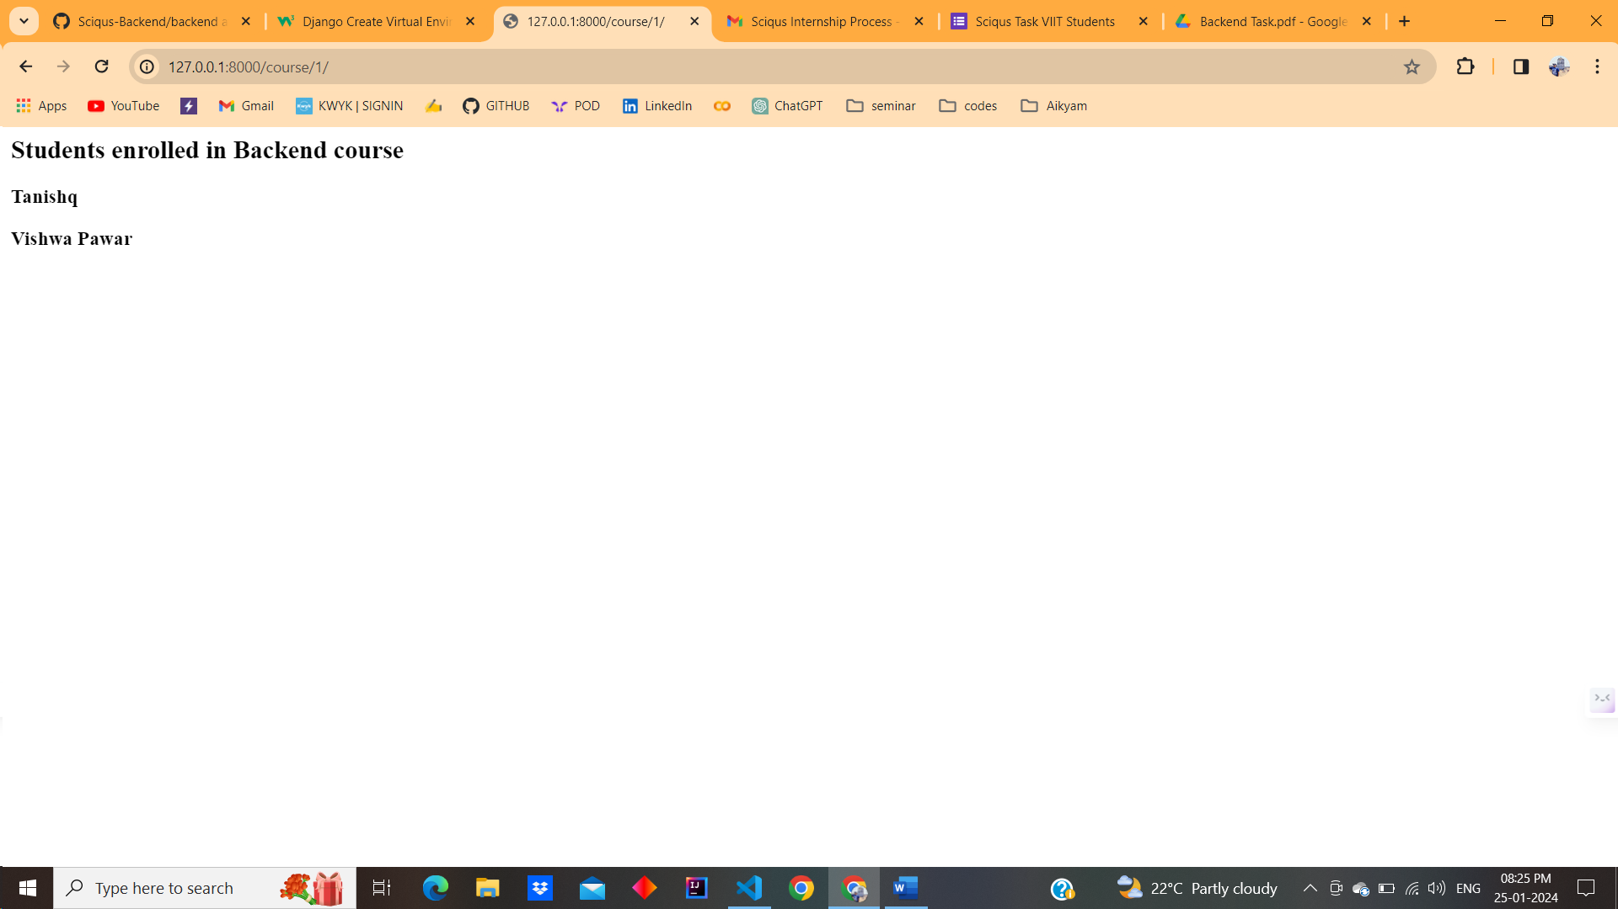

* **Edit Student Details with Course Modification:**

def edit_student(request, student_id):

    student = get_object_or_404(Student, pk=student_id)

    if request.method == 'POST':

        form = StudentUpdateForm(request.POST, instance=student)

        if form.is_valid():

            form.save()

            return redirect('student_list')

    else:

        form = StudentUpdateForm(instance=student)

    return render(request, 'student/edit_student.html', {'form': form, 'student': student})

<form method="post" action="">

    {% csrf_token %}

    {{ form.as_p }}

    <button type="submit">Update</button>

  </form>

[**http://127.0.0.1:8000/student/1/edit/**](http://127.0.0.1:8000/student/1/edit/)

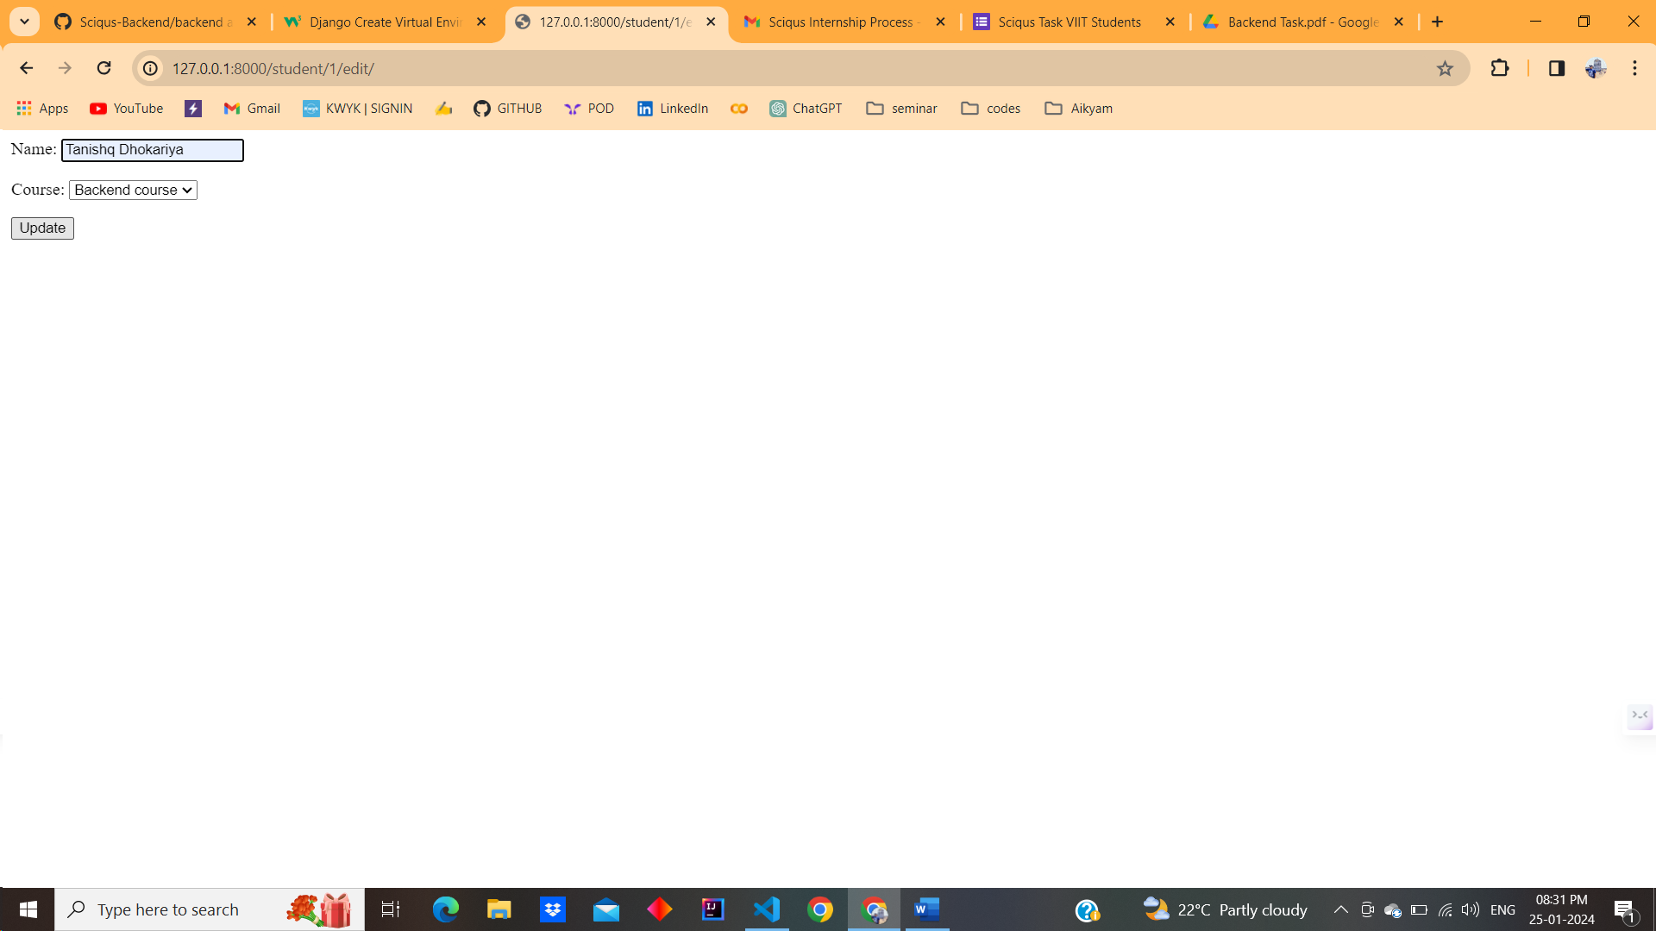

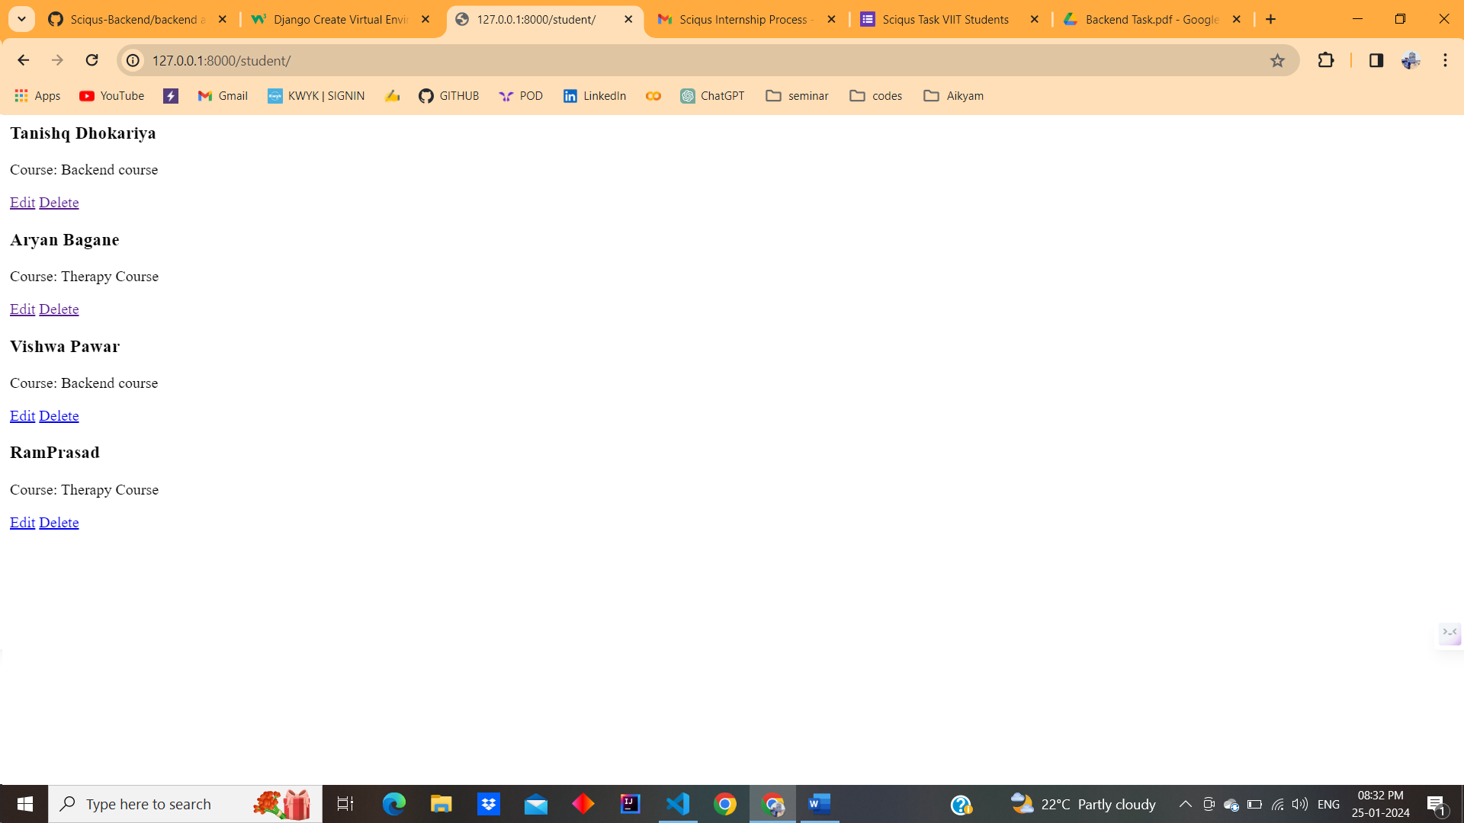

* **Delete Students with Course Deletion:**

def delete_student(request, student_id):

    student = get_object_or_404(Student, pk=student_id)

    if request.method == 'POST':

        # Delete the student

        student.delete()

        # Redirect to the list of students or any other page

        return redirect('student_list')

    return render(request, 'student/delete_student.html', {'student': student})

<h2>Are you sure you want to delete {{ student.name }}?</h2>

<form method="post" action="">

  {% csrf_token %}

  <button type="submit">Yes, delete</button>

  <a href="{% url 'student_list' %}">Cancel</a>

</form>

[**http://127.0.0.1:8000/student/5/delete/**](http://127.0.0.1:8000/student/5/delete/)

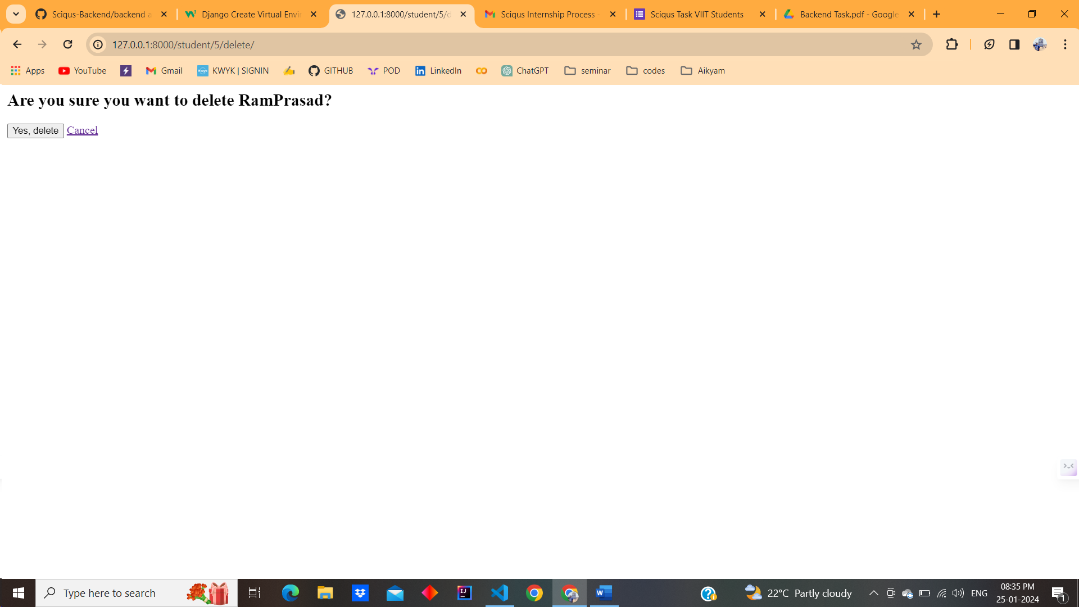

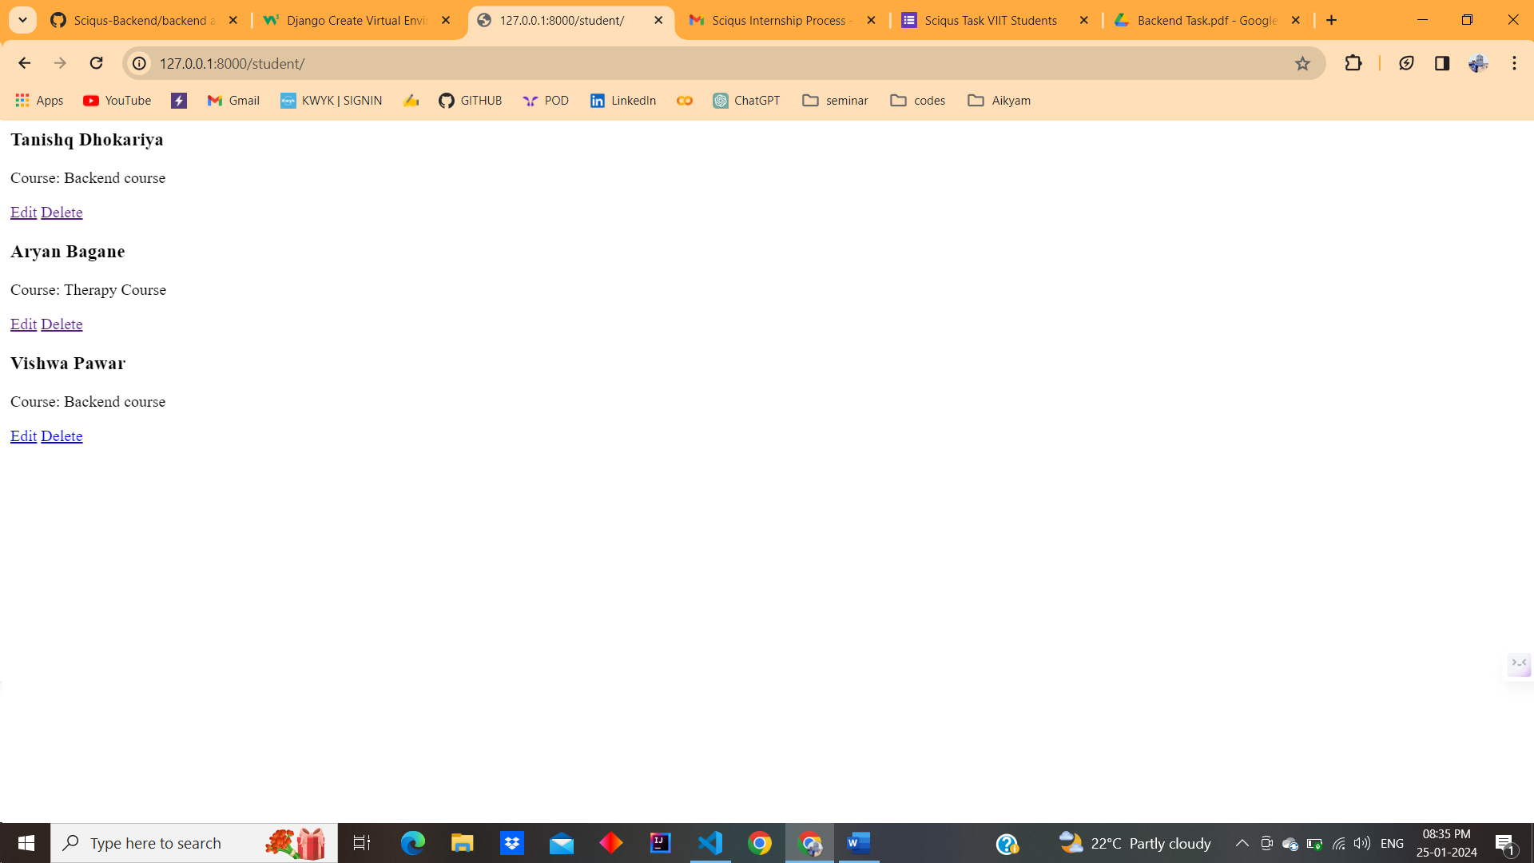

* **Include Transaction Management:**

@transaction.atomic

def edit_student(request, student_id):

    student = get_object_or_404(Student, pk=student_id)

    if request.method == 'POST':

        form = StudentUpdateForm(request.POST, instance=student)

        if form.is_valid():

            form.save()

            return redirect('student_list')

    else:

        form = StudentUpdateForm(instance=student)

    return render(request, 'student/edit_student.html', {'form': form, 'student': student})

